Designers use blocks, most often <div> elements, to create rectangular areas into which all content fits. There are only three rules:

* **Total area**: the space an element occupies *and* affects.
* **Float, clear and overflow**
* **Nested elements**

**Total Area**

Total width is how much horizontal space a block occupies. This includes the block’s margin, border, and padding. Calculating width, padding, and margin is often the biggest headache for designers, but it's easy to see how they work if you use the **box model**. The box model consists of the properties **margin, border,** and **padding**.

Margin is **outside** block elements, while padding is **within** them. This means that we use margin to separate a block from things around it, and padding to move a block's content away from its edges.

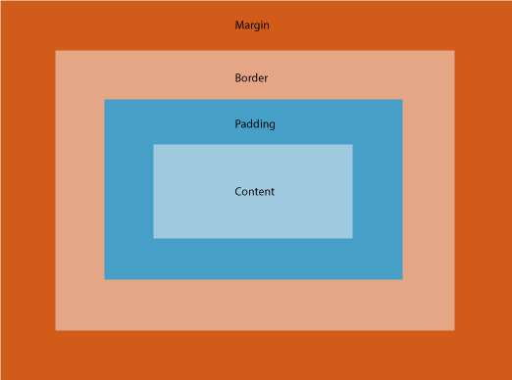

div{

padding-top: 25px;

padding-right: 50px;

padding-bottom: 75px;

padding-left: 100px;

}

copy

is equivalent to:

div{

padding: 25px 50px 75px 100px;

}

(The order flows clockwise, top -> right -> bottom -> left.)

Now, according to the box model, **the total width of an element is:**

**(Margin x 2) + (Border x 2) + (Padding x 2) + Content Width**

Calculating the height is trickier. Why? Because **vertical margins collapse**.

Ex:

HTML:

<div id="box-1">

</div>

<div id="box-2">

</div>

<div id="box-3">

</div>

CSS:

#box-1, #box-2, #box-3{

height: 100px;

width: 100px;

background-color: red;

}

#box-1{

margin: 20px;

}

#box-2{

margin: 30px;

}

#box-3{

margin: 40px;

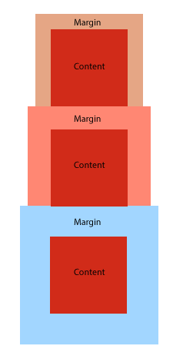

When the vertical margins of two elements are touching, **only the margin of the element with the largest margin value will be honored**, while the margin of the element with the smaller margin value will be collapsed to zero.

**There are other situations where elements do not have their margins collapsed**:

* floated elements
* absolutely positioned elements
* inline-block elements
* elements with overflow property set to anything other than visible (They do not collapse margins with their children.)
* cleared elements (They do not collapse their top margins with their parent block’s bottom margin.)